**MAMA’S CHEESIES: GRAPHICAL AND FUNCTIONAL ENHANCEMENT**

A Case Study Proposal

Presented to the

Computer Science Department

Faculty of Engineering

University of Santo Tomas

In Partial Fulfillment

of the Requirements for the Subject

ICS7 (Interface Design and Web Technologies)

by

**Matthew Ohrel. M. Uy**

**Kino Rafael R. Manalo**

**Mark Ian R. Eustaquio**

**Martin Adrian P. Casas**

**David Aristle T. Balba**

**Lance Ira C. Marquez**

**Louise Keren S. Emata**

**Nico Brent SJ. Miguelino**

**BS Computer Science**

Presented to

Asst. Prof. Vergil V. Reyes

December 2013

Table of Contents

I. Background of the Study 3

A. Name of Site to be Enhanced 3

B. Background of What the Site is for 3

C. Objectives of the Study 3

D. Significance of the Study 3

II. Analysis and Description of the Present System 4

A. Screen Captures of the Pages Based on its Current Functionalities 4

B. Comparative Analysis 8

C. Requirement Specifications 11

1) Functional 8

2) Non-Functional 12

# Background of the Study

## Name of Site to be Enhanced

Mama’s Cheesies: Graphical and Functional Enchancement

Link: http://mamascheesies.com

## Background of What the Site is for

The website is a first generation e-commerce website that offers a collection of handmade clothing and accessories to be purchased online. The site offers a wide variety of clothing like shirts, skirts, pants, tank tops and fabrics, it also provides different kinds of accessories like, jewelries, bags, purses, wallets and hear gears. They also provide a feedback report which indicates what they like and dislike about the products they sell and the website itself. You can also subscribe to the site in which you will receive news, updates, special offers, information on new items and sales.

## Objectives of the Study

* Our objective is to improve the functionality of the site, especially on the ordering process, the catalogue, and add a new feature that can compare chosen products.
* To improve our web developing and web designing skills.
* To be able to pinpoint the strengths and weaknesses of the web site.
* To enhance the design and the graphics of the website

## Significance of the Study

This study aims for the enhancement of graphics and design of this website, and also to improve some of its functionalities, specifically. The changes that will be imposed on this website is for the owner and also for the interested customers of Mama's Cheesies, for better usage and easier navigation.

# Analysis and Description of the Present System

## Screen Captures of the Pages Based on its Current Functionalities

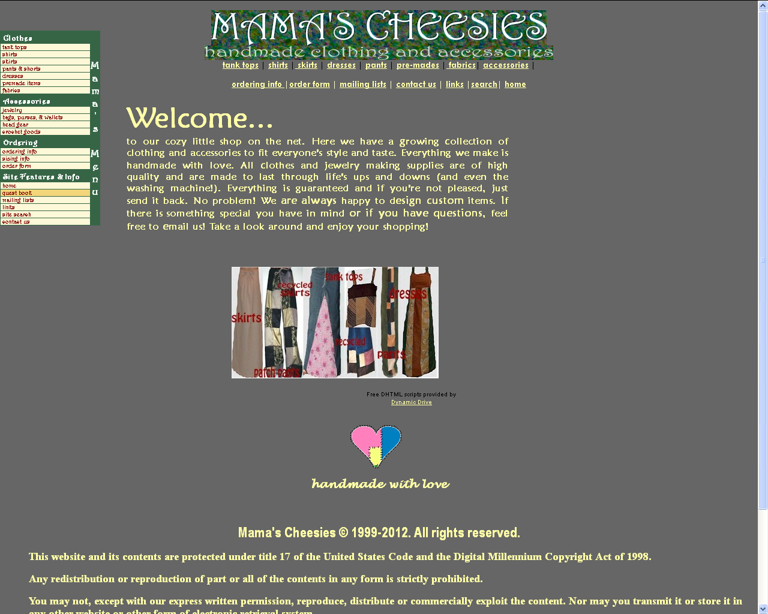

**Figure 2.A.1 –Home Page**

* There are so many gray areas in the website
* The description of the website is not pleasing to the eye of the users.
* Redundancy in the main menu.(Left side panel)

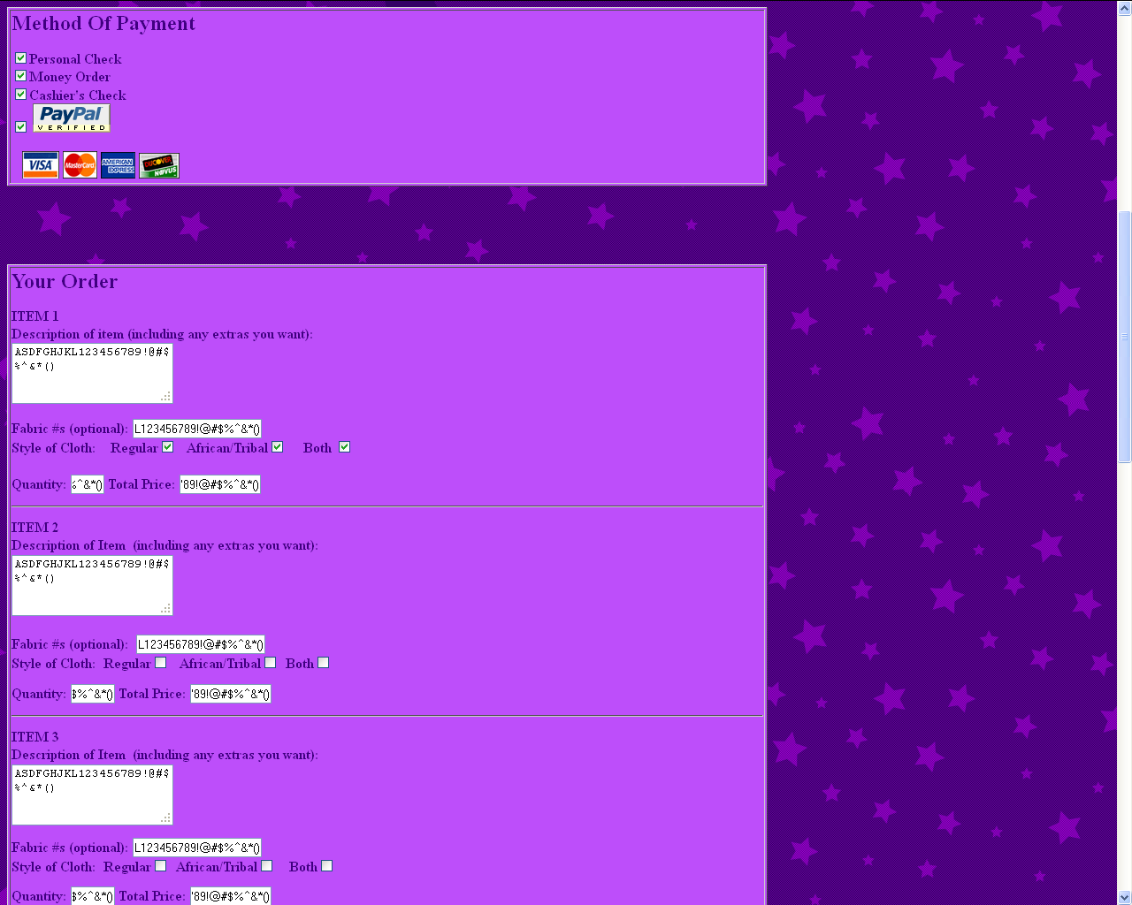

**Figure 2.A.2.– Order Form**

* No warning message when the user enters the right input or not.
* Instead of choosing a product from the item panel, the user has the responsibility to type in the textbox.

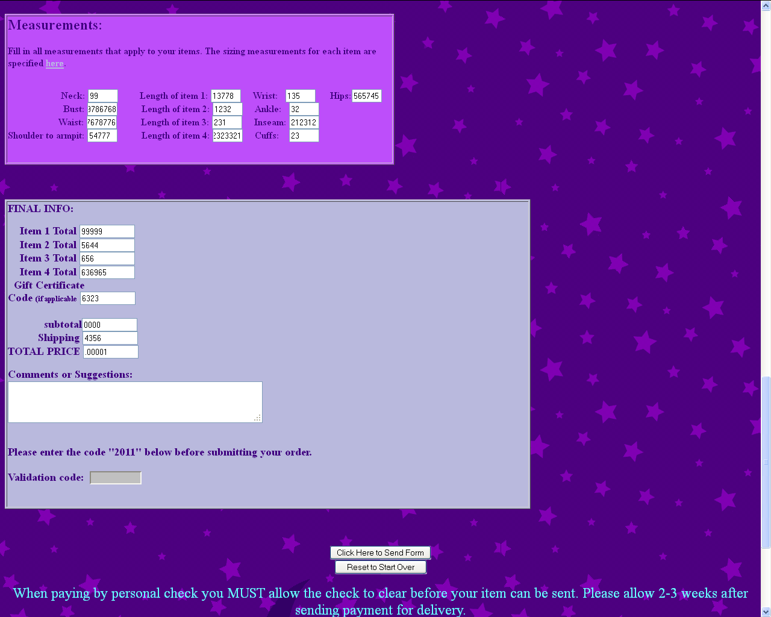

**Figure 2.A.3.– Order Form**

* The user can input anything that it wants making the site unsafe to use.
* Even if the required fields are not entered appropriately, the website will still display a thank you message that the transaction is successful.

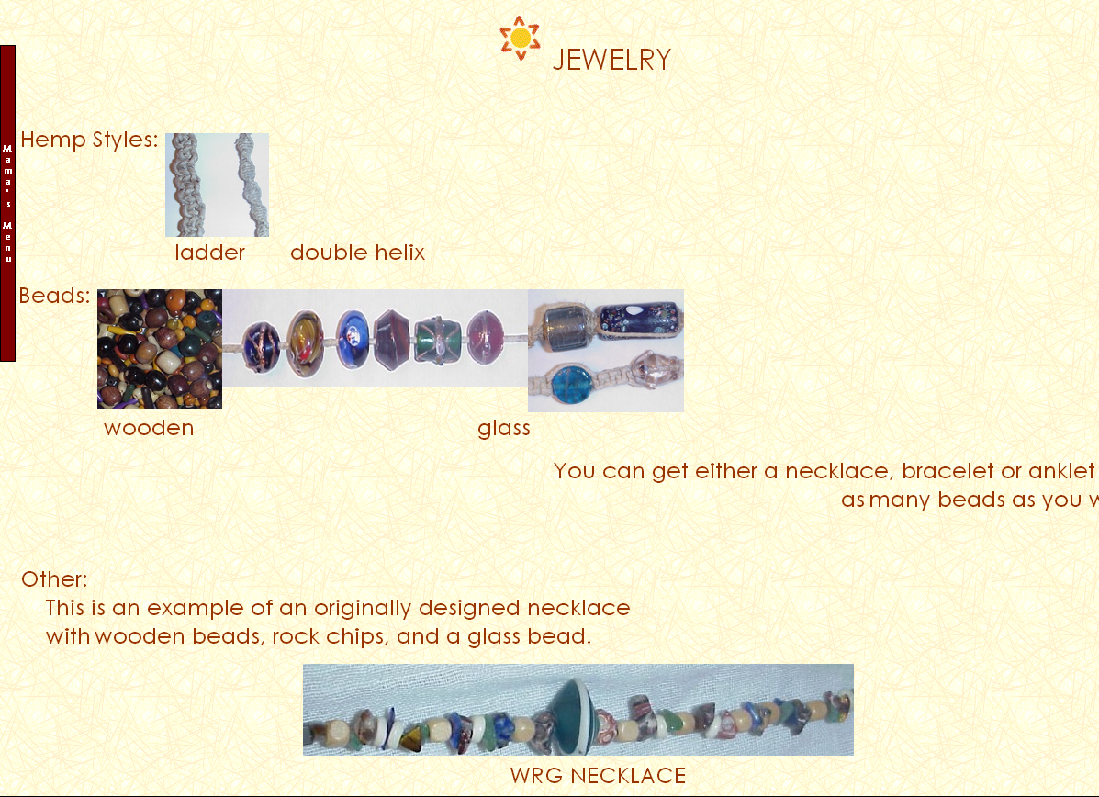

**Figure 2.A.4 – Jewelry Section**

## Comparative Analysis

|  |  |
| --- | --- |
| **Name of Site1: Mama’s Cheesies** | |
| **URL: http://www.mamascheesies.com/** | |
| **Brief Background**  Mama’s Cheesies is a first generation commercial Web site that sells clothing and other accessories online. The products that the site sells are handmade, including those that are made from recycled materials. | |
| **Site Objectives** | **Site Features** |
| * The Web site aims to sell high quality handmade clothing and accessories to people online. | * The site sells handmade clothing and accessories. * The customers are free to customize on what would their order’s design be. * Mama’s Cheesies also sells products made from recycled materials; they could be bought at low cost. |
| **Strengths** | **Weaknesses** |
| * It provides products online at a cheaper costs. * It displays a warning message if the values entered in some of the fields are not valid or empty. * There are pictures available for the customers to view the products. | * In the ordering form, there are no options on what the customer is going to order. * The Web site still displays a “thank you” message even if the required fields are not filled with inputs that are not included on their product lists. * When it comes to the method of payment, you would be able to select all the options (checkboxes) available. * It is the customer’s responsibility to type the cost (including the totals), quantities, and the type of the item of the preferred product. * It doesn’t provide the user instructions on what to do step-by-step. * The products and their respective prices are not displayed close to each other. |

|  |  |
| --- | --- |
| **Name of Site2: Leoneck** | |
| **URL: http://www.leoneck.ch/en/** | |
| **Brief Background**  A website that provides hotel reservation services. The hotel will surprise you with cheerful decorations of different contemporary Zurich artists. 80 rooms with free internet connection.  1.bmp | |
| **Site Objectives** | **Site Features** |
| * Aims to provide hotel reservations for customers online/ | * It has a 3d view of what the hotel looks like inside. |
| **Strengths** | **Weaknesses** |
| * It provides reservation online at a cheaper cost. * It has facilities, restaurants, comfort rooms, gym, swimming pool etc. | * It is too graphic heavy |

|  |  |
| --- | --- |
| **Name of Site2: arngren** | |
| **URL: http://arngren.net/** | |
| **Brief Background**  A website that provides selling of used products.  1.bmp | |
| **Site Objectives** | **Site Features** |
| * Aims to sell various items online. | * It has a feature that can browse the things you wanted to buy. |
| **Strengths** | **Weaknesses** |
| * It enables the user to buy products online at a cheaper cost. * It enables the user to sell their used products. | * It is too graphic heavy * It is only good for people who understand the language. * The items are not organized. |

## Requirement Specifications

### Functional

* The catalogue feature should have these modifications:
* It must have the specified details. i.e. image, description, price status(available or sold out).
* It should also have its table of contents so that the user will be easier for him to search for his/her desired product.
* Added a new feature **“Compare Products”**, these feature will help the user analyze whether which product is better than the other or not.
* In the billing process feature, There will be a lot of adjustments and enhancements:
* Modify the billing option by making it simpler. The user should input only the following; i.e. name, address, card number and the important details that the site should need in order to sell the product.
* The optionhas a lot of unnecessary labels which we will remove.
* The payment method should only have 1 way of making the payment. Before, the user can choose multiple options.
* Removing the description label, which allows the user to input the desired product and replacing it with a choice box.
* Adjusting the homepage, making it more livelier and more energetic so that the user will be more entertained.
* Also including the homepage buttons, the site should transform from a generation 1 website to generation 4 website.

### Non-Functional

* Using HTML5 and CSS language
* Operating System used is Windows.
* Web developing Softwares i.e. Github, Dreamweaver will be included.
* Most sites used would be CodeAcademy and other HTML sites.
* Changing the text boxes into options in the chosen site.